**CSE523** Machine Learning

Project: Shipment Price Prediction

Weekly Project Report: April 08, 2023

Team: **Revolution**

|  |  |
| --- | --- |
| Team Members | Enrolment-ID |
| Deep Patel | AU2040250 |
| Roshni Navdiya | AU2040114 |
| Aditya Padhariya | AU2040151 |
| Keval Parmar | AU1940133 |



* **Task Performed this week:**

1. Converted the X_train dataset into a NumPy array, which can be used as input to the Gradient boost model.
2. This line trains the Gradient boost Regressor model on the input data. array1 is the NumPy array containing the input features, and Y1_train is a NumPy array or pandas Series containing the corresponding target values (i.e., the values we want the model to predict). The .fit() method fits the model to the input data, using gradient boosting to minimize the mean squared error loss function.
3. The loaded model is then used to make a prediction using the .predict() method, which takes an input feature matrix as its argument.

* **Outcomes of the tasks performed:**

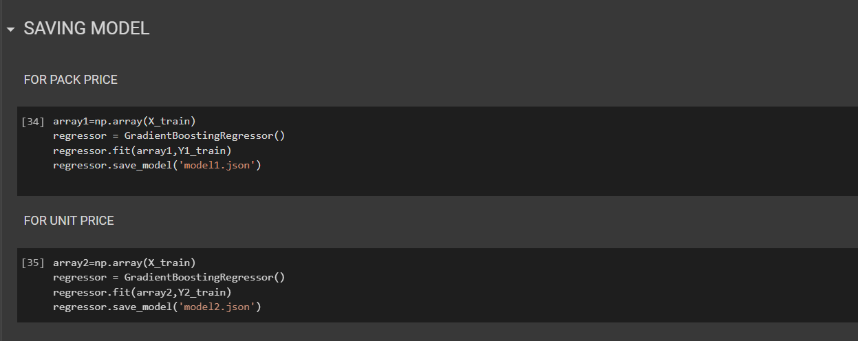

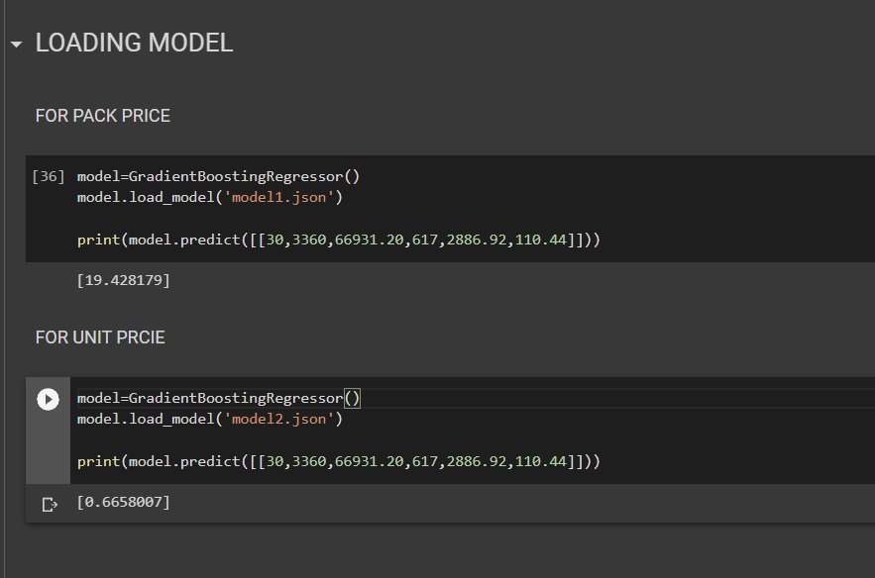

* **Tasks to be performed in the upcoming week:**

1. Model evaluation and conclusions
2. Parameter tweaking and assessment of models based on significant hyperparameters